Cs101 final term Mcqs And Questions 2023
- A primary prevention techniques is to filter traffic passing through a point in the network, usually with a program called a FIREWALL.
- Masquerading as a party other then one’s self is known as SPOOIFING.
- SPAM FILTERS which are firewalls designed to block unwanted email.
- Another preventative tool that has filtering connotations is the PROXY SERVER. A proxy server is a software unit that acts as an intermediary between a client and a server with the goal of shielding the client from adverse actions of the server.
- particular kind of service (FTP, HTTP, telnet, etc.).
- FTP proxy server could check all incoming files for the presence of known viruses and block all infected files.
- auditing software, a system administrator can detect a sudden increase in message traffic at various locations within the administrator’s realm, monitor the activities of the system’s firewalls, and analyse the pattern of requests being made by the individual computers in order to detect irregularities.( short Q)
- antivirus software, which is used to detect and remove the presence of known viruses and other infections.
- authentication—making sure that the author of a message is, in fact, the party it claims to be.
- A prime example is the secure version of HTTP, known as HTTPS which is used by most financial institutions to provide customer which secure internet access to their accounts. The backbone of HTTPs is the protocol system known as Secure socket layer (SSL), which was originally developed by Netscape to provide secure communication to link between web clients and servers.(Short Question)
- One key is known as public key , is used to encrypt message ; the older key known as the private key, is required to decrypt message.( MCQS + Short Question)
- Certificate authorities whose task to be maintain accurate lists of parities and their public key.
- Certificates. A certificates is a package containing a party’s name and that party’s public key.
- In this manner, the holder of the private key can produce a bit pattern, called a digital signature, that only that party knows how to produce. By attaching that signature to a message, the sender can mark the message as being authentic.
- US – Computer Fraud and Abuse Act passed in 1948
- US- Electronic communication privacy Act (ECPA)
- National assembly pass new cybercrime law in 2016.
- Pakistan – applicable Security acts (Short Question + MCQS)
- Prevention of electronic crime ordinance ,2007
- Electronic transaction ordinance , 2002-2008
- Pakistan Telecommunication (Re-Organization ) Acts 1996
- Wireless Telegrapy Act 1933
- Telegraph Act , 1885
- Federal Investigation Agency Act, 1974 (IMP MCQS)
- Payments and electronic fund Transfer Act , 2007
- Algorithm set of steps that define how a task is performed. ( Short Question+ MCQS)
- Making a cup of Tea ( IMP LONG QUESTION)
- Put water in kettle
- Boil water
- Put tea in water
- Add milk
- Stir
- Add sugar
- Put tea in cup
- Fetch cup
- CONVERT KM TO METERS Multiply the input with 1000.
- MACHINE CYCLE (IMP SHORT + LONG QUESTION)
- Fetch an instruction.
- Decode the instruction.
- Execute the instruction
- Many researchers believe that every activity of the human mind, including imagination, creativity, and decision making, is actually the result of algorithm execution

- Unambiguous The information in the state of the process must be sufficient to determine uniquely and completely the actions required by each step.

- A single algorithm can be represented in many ways

- F = (9/5)C + 32

- A program is a representation of an algorithm.

- The term program usually refers to a formal representation of an algorithm designed for computer application

- A process already to be the activity of executing a program

- . In the case of humans, this might be a traditional natural language (English, Spanish, Russian, Japanese) or perhaps the language of pictures , ( IMP SHORT QUESTION)

- As the terminology used has more than one meaning.

- Each primitive has its own syntax and semantics. Syntax refers to the primitive’s symbolic representation; semantics refers to the meaning of the primitive

- DIFFERENCE BETWEEN NATURAL LANGUAGES AND PRIMITIVE ( IMP SHORT QUESTION)
In the case of humans, this might be a traditional natural language (English, Spanish, Russian, Japanese) or perhaps the language of pictures
Computer science approaches these problems by establishing a well-defined set of building blocks from which algorithm representations can be constructed. Such a building block is called a primitive

PSEUDOCODE ( IMP DEF)
- a formal programming language in favour of a less formal, more intuitive notational system known as pseudocode a pseudocode is a notational system in which ideas can be expressed informally during the algorithm development process.
- loose versions of the languages Algol and Pascal ( Java and C languages has proliferated, again because most programmers will have at least a reading knowledge of these languages.)
- A pseudocode must have a consistent, concise notation for representing recurring semantic structures ( IMP MCQS)
- This pseudocode structure directly follows the equivalent Python assignment statement (IMP MCQS)
- While-Structure Another common semantic structure is the repeated execution of a statement or sequence of statements as long as some condition remains true ( IMP MCQS)
- def name():
pseudocode representation of a function called Greetings that prints the message “Hello” three times page 166 imp diagram IMP LONG QUESTION
- the following loosely defined problem-solving phases presented by the mathematician G. Polya in 1945
- Phase 1. Understand the problem.
- Phase 2. Devise a plan for solving the problem.
- Phase 3. Carry out the plan.
- Phase 4. Evaluate the solution for accuracy and for its potential as a tool for solving other problems. IMP SHORT QUESTION
- The idea is that by breaking the original problem into subproblems stepwise refinement

- stepwise refinement is a top-down methodology in that it progresses from the general to the specific
a bottom-up methodology progresses from the specific to the genera( IMP MCQS + SHORT QUESTION)
- Figure 82: The sequential search algorithm in pseudocode page 173 diagram IMP LONG QUESTION
- The repetitive use of an instruction or sequence of instructions is an important algorithmic concept iterative structure known as the loop
- , in which a collection of instructions, called the body of the loop, is executed in a repetitive fashion under the direction of some control process
- the use of a loop structure produces a higher degree of flexibility
- The control of a loop consists of the three activities initialize, test, and modify
- Figure 83: Components of repetitive controll page 175 diagram (IMP LONG QUESTION +MCQS)
- PAGE 176 Example 1 is very IMP
DIFFERENCE BETWEEN A PERTEST AND POSTTEST
- loop structure referred to as a pertest loop (since the test for termination is performed before the body is executed) and the repeat loop structure referred to as a post test loop (since the test for termination is performed after the body is executed).( IMP LONG QUESTION+ SHORT QUESTION + MCQS)
- Recursive Control The binary search algorithm is similar to the sequential search.
- In general, a recursive function is designed to test for the termination condition (often called the base case or degenerative case
- Algorithm Efficiency today’s machines are capable of executing millions or billions of instructions each second
- the sequential search algorithm will interrogate an average of n⁄2 entries
- the binary search algorithm will interrogate at most log2n entries
- log2 n represents the base two logarithm of n
- Software Verification Distinction between Program believed to be correct and the program that is correct
- Software Failure Fatal Therac-25 X-ray Radiation
- In 1986, a man in Texas received between 16,500-25,000 radiations in less than 10 sec, over an area of about 1 cm
- The root cause of the incident was a SW failure
- Welsch NHS IT Failure This was a technical issue of software not the security issue
- Unfortunately, writing programs in a machine language is a tedious task that often leads to errors that must be located and corrected (a process known as debugging) before the job is finished
- In the 1940s, researchers simplified the programming process by developing notational systems by which instructions could be represented in mnemonic rather than numeric form.

HLT C000
- using mnemonics. (Here we have used LD, ADDI, ST, and HLT to represent load, add, store, and halt. Moreover, we have used the descriptive names Price, Shipping Charge, and Total Cost to refer to the memory cells at locations 6C, 6D, and 6E, respectively. Such descriptive names are often called program variables or identifiers.)
- Once such a mnemonic system was established, programs called assemblers were developed to convert mnemonic expressions into machine language instructions
- A mnemonic system for representing programs is collectively called an assembly language
- second-generation languages, the first generation being the machine languages themselves a program written in an assembly language is inherently machine dependent – that is, the instructions within the program
- third generation of programming languages FORTRAN (Formula Translator), COBOL (Common Business-Oriented Language), IMP MCQS
- Once this collection of high-level primitives had been identified, a program, called a translator
- Thus, these translation programs were often called compilers
- An alternative to translators, called interpreters, emerged as another means of implementing third generation languages.
- Grace Hopper, who is recognized as the developer of the first compiler
- third-generation language in which German terms, rather than English
- natural languages (such as English, German, and Latin) are distinguished from formal languages (such as programming languages) in that the latter are precisely defined by grammars, whereas the former evolved over time without formal grammatical analysis.(IMP QUESTION)
- American National Standards Institute and the International Organization for Standardization have adopted and published standards for many of the popular languages
- even in the case of highly standardized languages, compiler designers often provide features, sometimes called language extensions,
- In reality, the development of programming languages has not progressed in this manner but has developed along different paths as alternative approaches to the programming process (called programming paradigms) have surfaced and been pursued. Consequently, the historical development of programming( IMP QUESTION)
- four paths representing the functional, object-oriented, imperative, and declarative paradigms,
- The imperative paradigm, also known as the procedural paradigm, represents the traditional approach to the programming process. It is the paradigm on which Python and our pseudocode are based as well as the machine language. As the name suggests, the imperative paradigm defines the programming process to be the development of a sequence of command (IMP MCQS+SHORT QUESTION)
- the imperative paradigm tells us to approach the programming process by finding an algorithm to solve the problem at hand and then expressing that algorithm as a sequence of commands.
- Figure 92: The evolution of programming paradigms page 196 IMP MCQS DIAGRAM
- In contrast to the imperative paradigm is the declarative paradigm,
- More precisely, a declarative programming system applies a pre-established general-purpose problem-solving algorithm to solve problems presented to it.
- functional paradigm. Under this paradigm a program is viewed as an entity that accepts inputs and produces outputs . Mathematicians refer to such entities as functions, which is the reason this approach is called the functional paradigm. Under this paradigm a program is constructed by connecting smaller predefined program units (predefined functions (IMP MCQS+SHORT QUESTION)
- LISP programming language (a prominent functional programming language) by the expression
- Another programming paradigm (and the most prominent one in today’s software development) is the object-oriented paradigm, which is associated with the programming process called object-oriented programming (OOP). Following this paradigm, a software system is viewed as a collection of units, called objects, each of which is capable of performing the actions that are immediately related to itself as well as requesting actions of other objects.
- Each of these objects would encompass a collection of functions (called methods in the object oriented vernacular.
- This description of the object’s properties is called a class.
- (An object that is based on a particular class is said to be an instance of that class.
- High-level programming languages allow locations in main memory to be referenced by descriptive names rather than by numeric addresses. Such a name is known as a variable, (IMP SHORT QUESTION)
- Such a type is known as a data type and encompasses both the manner in which the data item is encoded and the operations that can be performed on that data SHORT QUESTION

DIFFERENCE BETWEEN TYPE INTEGER AND TYPE FLOAT)

- the type integer refers to numeric data consisting of whole number two’s complement notation.
The type float real numeric data tha other than whole numbers stored in floating-point(IMP SHORT + LONG QUESTION +MCQS)
- Other common data types include character and Boolean. The type character refers to data consisting of symbols, probably stored using ASCII or Unicode
- The type Boolean refers to data items that can take on only the values true or false. Operations on data of type
- The data types that are included as primitives in a programming language, such as int for integer and char for character, are called primitive data types. As we have learned, the data types such as: integer, float, character, and Boolean are common primitives. Other data types that have not yet become widespread primitives include images, audio, video, and hypertext. However, types such as GIF, JPEG, and HTML might soon become as common as integer and float.
- variables in a program are often associated with data structure, which is the conceptual shape or arrangement of data
- One common data structure is the array, which is a block of elements of the same type such as a onedimensional list, a two-dimensional table with rows and columns, or tables with higher dimension
- (IMP DEFINITION)
an individual element can be identified by means of integer values called indices
FOR EXAMPLE:
For example, in C (and its derivatives C++, Java, and C#) indices start at 0
. In contrast, indices start at 1 in a FORTRAN
- o an array in which all data items are the same type, an aggregate type (also called a structure, a record, or sometimes a heterogeneous array) is a block of data in which different elements can have different types.
- (IMP SHORT QUESTION)
C by the statemen
ANSWER:
struct
{char Name[25];
int Age;
float Skill Rating;
} Employee;
which says that the variable
- The most basic imperative statement is the assignment statement
- Z = X + Y; the sum of X and Y be assigned to the variable Z. The semicolon at the end of the line, which is used to separate statements in many imperative languages
In some other languages (such as Ada) the equivale- lent statement would appear
Z := X + Y;
- A control statement alters the execution sequence of the program. Of all the programming constructs.
if (condition)
Statement A
else
Statement B.
(IMP MCQS)
- float f=3.5;
if (CGPA>=3.0)
cout< <” Give scholarship”
else
cout <<”Sorry you do not Qualify for the scholarship”
- The loop control structure iterates a set of instructions based on the provided condition
- This loop will execute 5 times as follows:
- Such simultaneous execution of multiple activations is called parallel processing or concurrent processing
- . True parallel processing requires multiple CPU cores
- Many modern computer applications are more easily solved in the context of parallel processing than in the more traditional context involving a single sequence of instructions
- what we have informally referred to as an activation is called a task in the Ada vernacular and a thread in Java.
- C-language has the following arithmetic operators
- +, -, and * are the same as used in the mathematic
+ Addition
- Subtraction
* Multiplication
/ Division
% Modulus
The remaining “1” can be acquired by using the modulus operator (%).

- IMP MCQS
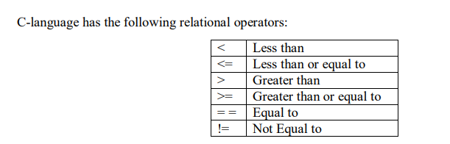
- Now if the result after comparison of two variables is True, then if statement returns value 1.
- And if the result after comparison of two variables is False, then if statement returns value 0.
if(a>b)

- . C-language Logical Operators are used if we want to compare more than one condition

- IMP MCQS

- 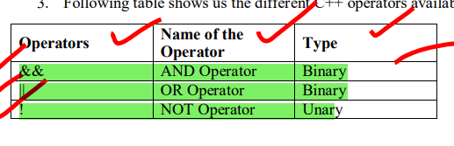
IMP DEFINITION

- 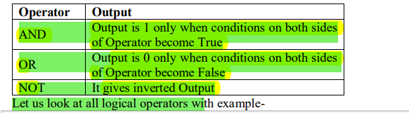

- IMP LONG QUESTION
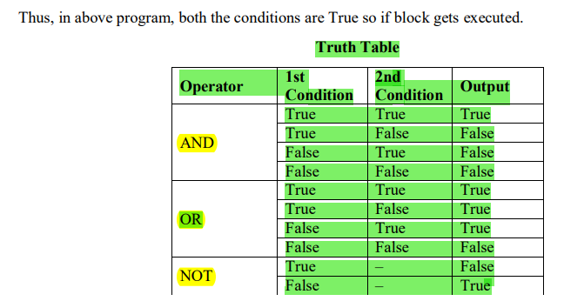

- quantitative techniques, called metrics, for measuring the properties of software.
- Some researchers, sometimes called practitioners, work toward developing techniques for immediate application, whereas others, called theoreticians, search for underlying principles and theories on which more stable techniques can someday be constructed
- Software errors f $5 million by the Bank of New York
- computer-aided software engineering (CASE),
- integrated development environments (IDEs)
- The most fundamental concept in software engineering is the software life cycle
- the case of other products, the maintenance phase tends to be a repair process, whereas in the case of software, the maintenance phase tends to consist of correcting or updating.
- IMP SHORT QUESTION
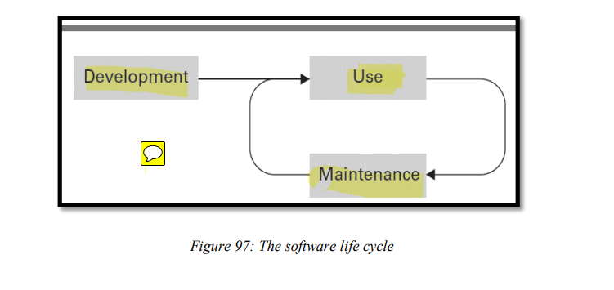

- The major steps in the traditional software development life cycle SDLC there are three major steps
requirements analysis, design, implementation, and testing
- Requirements Analysis: The software life cycle begins with requirements analysis
Goal : define how the outside world will interact with the system.

- stakeholders (future users as well as those with other ties, such as legal or financial interests) of the proposed system. In fact, in cases where the ultimate user is an entity government agency
- commercial off-the-shelf (COTS
- These requirements are recorded in a document called a software requirements specification.
- IMP SHORT QUESTION
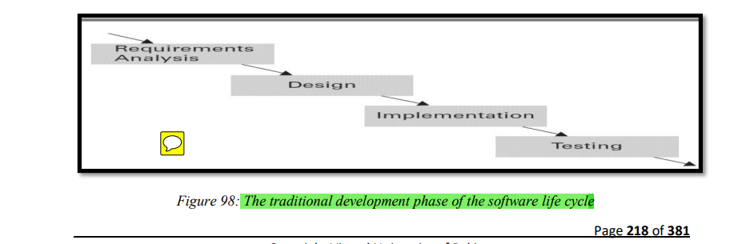
- From a lay- person’s perspective, requirements analysis is often equated with deciding what a software system is to do, whereas design is equated with deciding how the system will do it
- software analyst (sometimes referred to as a system analyst) a and a programmer. The former is a person involved with the entire development process
The latter is a person involved primarily with the implementation step (DIFFERENCE BETWEEN)
- Testing is now recognized as only one segment in the overall struggle for quality assurance
- Before using the software the testing is necessary the benefit of it that the errors are search and then remove these error by the debugging process( SHORT DEFINITION)
- water- fall model, an analogy to the fact that the development process was allowed to flow in only one direction. water- fall model and the “free-wheeling,” trial-and-error (SHORT QUESTION + MCQS)
- process that is often vital to creative problem solving. This is illustrated by the emergence of the incremental model for software development. Following this model, the desired software system is constructed in increments, the first being a simplified version of the final product with limited functionality. Once this version has been tested and perhaps evaluated by the future user, more features are added and tested in an incremental manner until the system is complete (SHORT DEFINITION)
- Another model that represents the shift away from strict adherence to the waterfall model is the iterative model
- A significant example of iterative techniques is the rational unified process (RUP, rhymes with “cup”) that was created by the Rational Software Corporation, which is now a division of IBM
- These guidelines, along with CASE tools to support them, are marketed by IBM.
- non-proprietary version, called the unified process, that is available on a non-commercial basis.
- prototyping in which incomplete versions of the proposed system, called prototypes, are built and evaluated. In the case of the incremental model these prototypes evolve into the complete, final system, a process known as evolutionary prototyping. In a more iterative situation, the prototypes may be discarded in Favor of a fresh implementation of the final design. This approach is known as throwaway prototyping. An example that normally falls within this throwaway category is rapid prototyping in which a simple example of the proposed system is quickly constructed in the early stages of development. Such a prototype may consist of only a few screen images that give an indication of how the system will interact with its users and what capabilities it will have.
- Perhaps the most pronounced shift from the waterfall model is represented by the collection of methodologies known as agile methods
- , One example of an agile method is extreme programming (XP)
- XP model, software is developed by a team of less than a dozen individuals
- agile methods are characterized by flexibility
- division of software into manageable units, generically called modules, each of which deals with only a part of the software’s overall responsibility.
- context of the imperative paradigm, modules appear as functions. In contrast, the object-oriented paradigm uses objects as the basic modular constituents
- modular structure depicted by the structure chart shown in Figure 99, in which functions are represented by rectangles and function dependencies (implemented by function calls) are represented by arrows IMP CHART
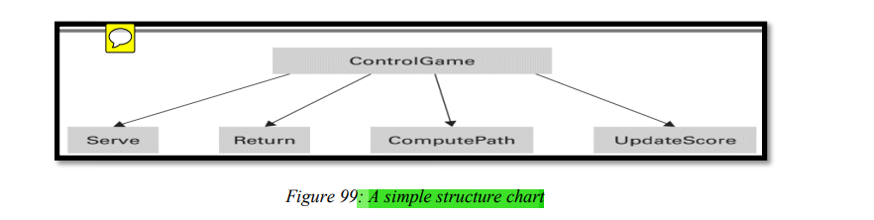
- minimize the linkage between modules (known as intermodular coupling)
- Intermodular coupling occurs in several forms. One is control coupling, which occurs when a module passes control of execution to another, as in a function call.
- data coupling, which refers to the sharing of data between modules. If two modules interact with the same item of data, then modifications made to one module may affect the other
- global data, which are data items that are automatically available to all modules throughout the system, as opposed to local data items that are accessible only within a particular module
- The term cohesion refers to this internal binding or, in other words, the degree of relatedness of a module’s internal parts
- A weak form of cohesion is known as logical cohesion
- A stronger form of cohesion is known as functional cohesion
- f information hiding, which refers to the restriction of information to a specific portion of a software system
- It is important to note that information hiding has two incarnations—one as a design goal, the other as an implementation goal. A module should be designed so that other modules do not need access to its internal information, and a module should be implemented in a manner that reinforces its boundaries. Examples of the former are maximizing cohesion and minimizing coupling. Examples of the latter involve the use of local variables, applying encapsulation (IMP QUESTION)
- “black box” whose interior features can be ignored by its user
- the object-oriented programming languages C++, Java, and C# C++ is associated with the C++ Standard Template Library, the Java programming environment is accompanied by the Java Application Programmer Interface (API), and C# programmers have access to the .NET Framework Class Library IMP QUESTION
- component, which is, by definition, a reusable unit of software. In practice, most components are based on the object oriented paradigm
- Research in the development and use of components has led to the emerging field known as component architecture (also known as component-based software engineering) in which the traditional role of a programmer is replaced by a component assembler (IMP MCQS)
- A design pattern is a pre-developed model for solving a recurring problem in software design
- the Adapter pattern provides a standard approach to “wrapping
- Java programming environments provided by Oracle and the .NET Framework provided by Microsoft
- The origins of design patterns lie in the research of Christopher Alexander in traditional architecture
- The Factory Design Pattern is a commonly used design pattern where we need to create Loosely Coupled System. Basically, it comes under Creational Pattern and it is used to create instance and reuse it. Factory Pattern is based on real time factory concept
- Application Service Providers (ASPs)
- software quality assurance (SQA) groups, which are charged with overseeing and enforcing the quality control systems adopted by the organization
- IEEE Standard for Software Reviews, known as IEEE 1028
- This is an instance of the proposition known as the Pareto principle, in reference to the economist and sociologist Vilfredo Pareto (1848−1923)
- Another software testing methodology, called basis path testing, is to develop a set of test data that ensures that each instruction in the software is executed at least once

DIFFERENCE BETWEEN GLASS AND BLACK BOX TESTING
- Techniques based on the Pareto principle and basis path testing rely on knowledge of the internal composition of the software being tested. They therefore fall within the category called glass-box testing, meaning that the software tester is aware of the interior structure of the software and uses this knowledge when designing the test. In contrast is the category called black-box testing, which refers to tests that do not rely on knowledge of the software’s interior composition
- An example of black-box testing is the technique, called boundary value analysis, that consists of identifying ranges of data, called equivalence classes, over which the software

DIFFERENCE BETWEEN BETA AND ALPHA TESTING
- Another methodology that falls within the black-box category is beta testing in which a preliminary version of the software is given to a segment of the intended audience with the goal of learning how the software performs in real-life situations before the final version of the product is solidified and released to the market. (Similar testing performed at the developer’s site is called alpha testing.)
- The purpose of system documentation is to describe the software’s internal composition so that the software can be maintained later in its life cycle
- The purpose of technical documentation is to describe how a software system should be installed and serviced (such as adjusting operating parameters, installing updates, and reporting problems back to the software’s developer)
- Research in human-machine interface design draws heavily from the areas of engineering called ergonomics, which deals with designing systems that harmonize with the physical abilities of humans, and cognatic, which deals with designing systems that harmonize with the mental abilities of humans. Of the two, ergonomics is the better understood, largely because humans
- three categories of documentation: user documentation, system documentation, and technical documentation. The purpose of user documentation is to explain the features of the software and describe how to use them (IMP MCQS + SHORT QUESTION)
- The GOMS (rhymes with “Toms”) model, originally introduced in 1954, is representative of the search for metrics in the field of human-machine interface design
- acronym GOMS—goals, operators, methods, and selection rules. In short, GOMS is a methodology that allows the actions of a human using an interface to be analysed as sequences of elementary steps
- GOMS is founded on features of human behaviour
- GOMS reemphasizes the role that human characteristics play in the field of human-machine interface design, even
- IMP DIFFERENCES
intellectual property law, much of which is based on the well-established principles of copyright and patent law. Indeed, the purpose of a copyright or patent is to allow the developer of a product to release that product (or portions thereof) to intended parties while protecting his or her ownership rights
- the rights of the developer are formally expressed in legal terms in a software license
- A software license is a legal agreement between the owner and user of a software product that grants the user certain permissions to use the product without transferring ownership rights to the intellectual property. IMP DEFINITION
- Patent laws were established to allow an inventor to benefit commercially from an invention typically 20 years from the date
- Research in Motion (RIM—the makers of the BlackBerry smartphones
- NPT a total of $612.5 million,
- array is a “rectangular” block of data whose entries are of the same type. The simplest form of array is the one-dimensional array, a single row of elements with each position identified by an index. A one-dimensional array with 26 elements could be used to store the number of times each alphabet letter occurs in a page of text, for example. A two-dimensional array consists of multiple rows and columns in which positions are identified by pairs of indices—
- In contrast to an array, recall that an aggregate type is a block of data items that might be of different types and sizes. The items within the block are usually called fields
- list, which is a collection whose entries are arranged sequentially
- The beginning of a list is called the head of the list. The other end of a list is called the tail
- A stack is a list in which entries are inserted and removed only at the head. An example is a stack of books
- he head of a stack is called the top of the stack. The tail of a stack is called its bottom or base. Inserting a new entry at the top of a stack is called pushing
- Removing an entry from the top of a stack is called popping an entry.
- as a last-in, first-out, or LIFO
- This LIFO characteristic means that a stack is ideal for storing items that must be retrieved in the reverse order from which they were stored
- (The term backtracking refers to the process of backing out of a system in the opposite order from which the system was entered
- A queue is a list in which the entries are removed only at the head and new entries are inserted only at the tail. people waiting to buy tickets at a theatre
- first-in, first-out, or FIFO (pronounced “FIE-foe”) structure, meaning that the entries are removed from a queue in the order in which they were stored
- A tree is a collection whose entries have a hierarchical organization similar to that of an organization chart of a typical company
- Each position in a tree is called a node
- The node at the top is called the root node
- The nodes at the other extreme are called terminal nodes (or sometimes leaf nodes)
- We often refer to the number of nodes in the longest path from the root to a leaf as the depth of the tree
- We refer to its immediate descendants as its children and its immediate ancestor as its parent
- we speak of nodes with the same parent as being siblings
- A tree in which each parent has no more than two children is called a binary tree.
- We call these smaller structures subtrees.
- Each such subtree is called a branch from the parent
- Being numeric values, these addresses themselves can be encoded and stored in memory cells. A pointer is a storage area that contains such an encoded address
- There we found that a register called a program counter is used to hold the address of the next instruction to be executed
- In fact, another name for a program counter is instruction pointer.
- (IMP DEFINITION)
The term database refers to a collection of data that is multidimensional in the sense that internal links between its entries make the information accessible from a variety of perspectives.
- flat file, which is a one-dimensional storage system, meaning that it presents its information from a single point of view
- Today, database technology, combined with data mining techniques,
- World Wide Web. The underlying theme of sites such as Google, eBay, and Amazon
- . A schema is a description of the entire database structure that is used by the database software to maintain the database. A subschema is a description of only that portion of the database pertinent to a particular user’s need (IMP SHORT QUESTION+MCQS)
- database application the two major application
1 application layer 2 database management layer
- Note that the application software does not directly manipulate the data- base. The actual manipulation of the database is accomplished by the database management system
(DBMS).

(IMP QUESTION FOR DIFFERENCES)
- to be concerned with whether the database is stored on a single machine or scattered among many machines within a network as a distributed database. Instead, the DBMS would deal with these issues, allowing the application soft- ware to access the database without concern for where the data is actually stored.
Still another reason for separating the user interface and actual data manipulation into two different software layers is to achieve data independence—the ability to change the organization of the database itself without changing the application software
- This conceptual view of the database is called a database model
- Relational database model portrays data as being stored in rectangular tables, called relations, which are similar to the format in which information is displayed by spreadsheet programs.

IMP DIFFERENCES
- A row in a relation is called a tuple (some say “TOO-pull,” others say “TUH-pull”). In the relation of Figure 110, tuples consist of the information about a particular employee. Columns in a relation are referred to as attributes
- A pivotal step in designing a relational database is to design the relations making up the database (IMP LINE)
- To retrieve the information about an employee, we must select the tuple with the appropriate identification attribute value from the EMPLOYEE relation, (IMP DEFINITION+MCQS)
- One operation we might want to perform on a relation is to select tuples possessing certain characteristics and to place these selected tuples in a new relation. To express this operation, we adopt the syntax (IMP MCQS)
- the SELECT operation, which extracts rows from a relation
- n, the PROJECT operation extracts columns
PROJECT EXAMPLE:
NEW2 <- PROJECT Job Title from NEW1
MAIL <- PROJECT Name, Address from EMPLOYEE
- This list is in the newly created (two-column) relation called MAIL
- IMP SHORT QUESTION
It is used to combine different relations into one relation. The JOIN of two relations produces a new relation whose attributes consist of the attributes from the original relation
BEST EXAMPLES FOR JOIN
C <- JOIN A and B where A.W = B.X
C <- JOIN A and B where A.W < B.
NEW1 <-JOIN ASSIGNMENT and JOB
where ASSIGNMENT.JobId = JOB.JobId
- This approach leads to an object-oriented database consisting of objects that are linked to each other to reflect their relationships.
- the links between the various objects are represented by lines connecting the related objects.
- The links between objects in an object-oriented database are normally maintained by the DBMS
- But objects that are created and added to a database must be saved after the program that created them terminates. Such objects are said to be persistent. Thus, creating persistent objects is a significant departure from the norm
- (IMP DEFINITION +MCQS) Maintaining DB Integrity
inexpensive database management systems for personal use are relatively simple systems. They tend to have a single objective—to shield the user from the technical details of the database implementation. The databases maintained by these systems are relatively small and generally contain information whose loss or corruption would be inconvenient rather than disastrous. a backup copy inconvenience is restricted to only a few people, and any financial loss is generally limited
IMP DEFINITION The Commit/Rollback Protocol
- A single transaction, such as the transfer of funds from one bank account to another, the cancellation of an airline reservation, or the registration of a student in a university course, might involve multiple steps at the database level.
- The point at which all the steps in a transaction have been recorded in the log is called the commit point
- the DBMS might find itself with a partially executed transaction that cannot be completed. In this case the log can be used to roll back
- This might mean that these additional transactions must also be rolled back, which might adversely affect still other transactions. The result is the problem known as cascading rollback.

DIFFERENCES BWTWEEN INCORRECT SUMMARY PROBLEM AND LOST UPDATE PROBLEM
- incorrect summary problem can arise if one transaction is in the middle of transferring funds from one account to another when another transaction tries to compute the total deposits in the bank
lost update problem, which is exemplified by two transactions, each of which makes a deduction from the same account
- locking protocol in which the items within a database that are currently being used by some transaction are marked as such. These marks are called locks
- Two types of locks are common—shared locks and exclusive locks.
- If a transaction is not going to alter a data item, then it requires shared access, meaning that other transactions are also allowed to view the data. However, if the transaction is going to alter the item, it must have exclusive access, meaning that it must be the only transaction with access to that data. (IMP DEFINITION FOR QUESTION + MCQS)
- wound-wait protocol (old transactions wound young transactions, young transactions wait for old ones
- A sequential file is a file that is accessed in a serial manner from its beginning to its end as though the information in the file were arranged in one long row. Examples include audio files, video files, files containing programs, and files containing textual document ( IMP SHORT DEFINITION)
- the end of a sequential file as the end-of-file (EOF)
- A classic example involving sequential files is payroll processing in a small company
- Hashing is a technique that provides similar access without such overhead. As in the case of an indexed system, hashing allows a record to be located by means of a key value.
- The data storage space is divided into several sections, called buckets,
- (This conversion from key values to bucket numbers is called a hash function.)
DIFFERENCE BETWEEN HASH FILE AND HASH TABLE
- When hashing is applied to a storage structure in mass storage, the result is called a hash file. When applied to a storage structure within main memory, the result is usually called a hash table. (IMP SHORT QUESTION)
- If a disproportionate num- Ber of keys happen to hash to the same bucket (a phenomenon called clustering),
- data mining is practiced on static data collections, called data warehouses
- (IMP SHORT QUESTION + MCQS)
Two common forms of data mining are class description and class discrimination. Class description deals with identifying properties that characterize a given group of data items, whereas class discrimination deals with identifying properties that divide two groups
- Another form of data mining is cluster analysis, which seeks to discover classes.
- More precisely, cluster analysis tries to find properties of data items that lead to the discovery of groupings.
- association analysis, which involves looking for links between data groups
- Outlier analysis is another form of data mining. It tries to identify data entries that do not comply with the norm
- sequential pattern analysis tries to identify patterns of behaviour over time.
- In some cases, the data collection process is readily apparent; in others it is subtle
- Artificial intelligence is the field of computer science that seeks to build autonomous machines - machines that can carry out complex tasks without human intervention. AI is helping to make Robots
- alleviate a person even 40 times a day
- Pepper Robot works as receptionist in Belgian hospital shown in
- This robot is able to take blood from the veins of the humans and it is more accurate than humans. It performs image processing to locate the veins and further confirmed by the ultrasound. (IMP SHORT QUESTION)
- An agent is a “device” that responds to stimuli from its environment. It is natural to envision an agent as an individual machine such as a robot, although an agent may take other forms such as an autonomous airplane, a character in an interactive video game, or a process communicating with other processes over the Internet (IMP SHORT QUESTION WITH EXAMPLE)
- Examples of sensors include microphones, cameras, range sensors, and air or soil sampling devices. Examples of actuators include wheels, legs, wings, grippers, and speech synthesizers.
- This could take the form of developing procedural knowledge (learning “how”) or storing declarative knowledge (learning “what”)
- DIFFERENCES BETWEEN engineering track and a theoretical track
To appreciate the field of artificial intelligence, it is helpful to understand that it is being pursued along two paths. One is the engineering track in which researchers are trying to develop systems that exhibit intelligent behaviour. The other is a theoretical track in which researchers are trying to develop a computational understanding of animal—especially human—intelligence. This dichotomy is clarified by considering the Linguists are interested in learning how humans process language and thus tend toward more theoretical pursuits.
- In the past the Turing test (proposed by Alan Turing in 1950) has served as a benchmark in measuring progress in the field of artificial intelligence
- Turing predicted that by the year 2000 machines would have a 30 percent chance of passing a five-minute
- The task of understanding general images is usually approached as a two-step process: (1) image processing, which refers to identifying characteristics of the image, and (2) image analysis, which refers to the process of understanding what these characteristics mean.( IMP SHORT QUESTION)
- syntactic analysis, whose major component is parsing. It is here that the subject of the sentence
- semantic analysis . which merely identifies the grammatical role of each word
- contextual analysis. It is at this level that the context of the sentence is brought into the understanding process.
- information retrieval and information extraction. Information retrieval refers to the task of identifying documents that relate to the topic at hand.

IMP SHORT + LONG QUESTION+MCQS
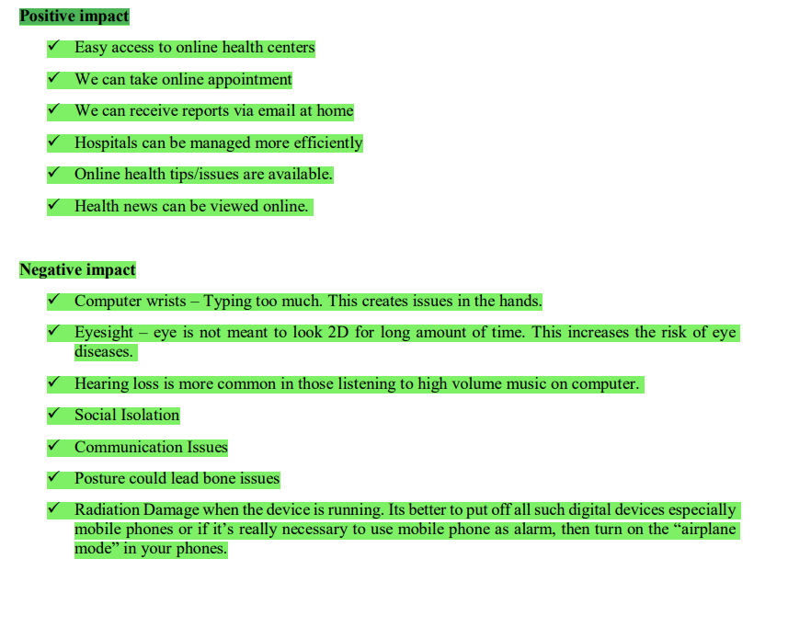

- Americans use about 680 pounds of paper per person, per year (POSITIVE IMPACT)
- This amounts to about 85 million tons of paper or 2 billion trees. (POSITIVE IMPACT)
- ⎫ The average American household throws away 13,000 pieces of paper (around 1 billion trees in total in USA) each year. Most in the form of packaging and junk mail . (POSITIVE IMPACT)
- ⎫ E-waste is sent to developing countries where people extract materials from these electronics such as gold, silver, and copper. (NEGATIVE IMPACT)
- Ethical issues are related to moral principles or the branch of knowledge dealing with these.
THREE TYPES OF ETHICAL ISSUES
- Privacy
- Digital Ownership
- Data Gathering
- Software licenses typically provide end users with the right to one or more copies of the software without violating copyrights.
- Software licenses typically are either proprietary, free or open source,
- Children’s Online Privacy Protection Act (COPPA) –
- Health Insurance Portability and Accountability Act (HIPPA)
- Electronic Communications Privacy Act ECPA
- Intellectual property (IP) is ideas, information and knowledge. In the University context IP can be viewed as the results and outcomes of research –
- Intellectual property rights (IPR) are specific legal rights which protect the owners of IP
- IMP LONG QUESTION
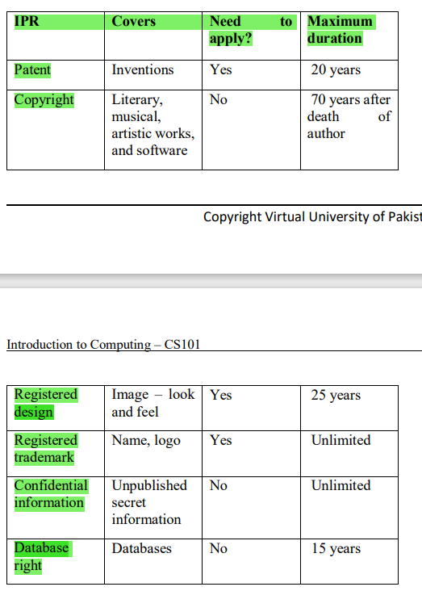
- Computer security, also known as cyber-security or IT security, is the protection of information systems from theft or damage to the hardware, the software, and to the information on them, as well as from disruption or misdirection of the services they provide.(IMP SHORT DEFINITION+MCQS)
- Computer Security is concerned with four main areas
- . Confidentiality
- Integrity:
- Availability:-
- Authentication:
- What is firewall?
A firewall is a security-conscious piece of hardware or soft-ware that sits between the Internet and your network with a single-minded task: preventing them from getting to us. The firewall acts as a security guard between the Internet and your local area network (LAN)
- Privacy uses the theory of natural rights, In North America, Samuel D. Warren and Louis D. Brandeis wrote that privacy is the "right to be let alone".
- EPIC ⎫ Electronic Privacy Information Centre
- ⎫ Independent non-profit research centre in Washington D.C. Its mission is to focus public attention on emerging Privacy and related human rights issues.
- PI Privacy International
- Social Issues of IT ( SHORT QUESTION)
- Communication Breakdown
- Defamation of Character
- Identity Theft
- Cyber Bullying
- Gaming Addiction
- Privacy
- Health & Fitness
- Education
- Terrorism & Crime
- Access to forbidden literature
- Content filtering, in the most general sense, involves using a program to prevent access to certain items, which may be harmful if opened or accessed
- Content filtering works by matching strings of characters.
- As email spam continues to become a major issue
- Important Laws SHORT QUESTION
- CAN-SPAM Act in US
- Canada’s Anti-Spam Legislation (CASL
- Anti-spam law in Europe
- Spam Act of 2003 in Australia
- Africa, Asia and South America have looser spam-law requirements
- Content Risks (IMP SHORT QUESTION)
- Illegal Content
- ⎫ Harmful Content
- ⎫ Harmful Advice
- Electronic Theft (IMP SHORT QUESTION)
- Online Fraud ⎫
- Online scam ⎫
- Identify theft
- One of the most important application software are the word processors
- One of the famous word processing software is MS Word, which is included in the Microsoft Office.
- File drop-down menu in earlier versions of Word. Recent documents are listed in the Recent Documents
- The ribbon is divided into Tabs, Groups, and Commands.
- The main ribbon is the Home Tab/ribbon. The home tab/ribbon in Excel and PowerPoint are similar.
- In the lower right-hand corner of some groups is a small down pointing arrow. These are referred to as Dialog Expanders or Launchers.
- types of Commands: (IMP SHORT +LONG QUESTION)
- Simple Buttons
- Drop-down menus Buttons
- Launchers (or Dialog Expanders) Buttons
- Simple Buttons work as Toggles or on/off switches
- Drop-down menu buttons will have a down arrow to the right of the command Change case control is an example
- simple button and a drop-down menu button. There are two buttons for these commands. The left button is a simple button and the right buttons is drop-down menu arrow button
- Underline is an example of a combination command
- The Mini Toolbar appears automatically whenever you select text and contains common text formatting command
- The Quick Access Toolbar provides easy access to the commands you use most frequently. The Save, Undo, Redo/Repeat, and Quick Print buttons appear on the Quick Access Toolbar by default
- IMP MCQS
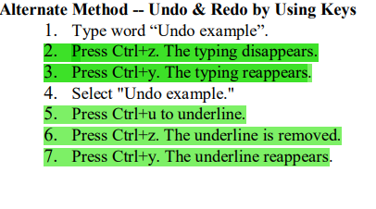
- The home ribbon is one of the most important ribbon available in the MS Word
- different important groups such as: Clipboard, Font, Paragraph, Styles and Editing
- Home ribbon is made up of the most used commands in Word. The first group on the Home ribbon is the Clipboard. Copy, Cut, Paste and Format Paste
- Clipboard group will open up the Clipboard pane
- Cut and Paste
- You can use Word's Cut feature to remove text from a document. You can use the Paste feature to place the information you cut anywhere in the same or another document
- The Office Clipboard is a storage area. When you cut, Word stores the data you cut on the Clipboard. You can paste the information that is stored on the Clipboard as often as you like
- Alternate Method—Cut with Keys Press Ctrl+x
- Alternate Method—Paste with Keys Press Ctrl+v.
- The second group of commands on the Home ribbon is the Font group includes font typefaces, font size, font effects colours and more The expander arrow in the Font group will open up the Font dialog window. (IMP SHORT QUESTION + MCQS)
- Basic Text Editing (Font Group Task) (Home Tab -> Font Group -> Font Arrow)
- MS Word (Paragraph Group third group on the Home ribbon is the Paragraph Paragraph Alignment Line Spacing spacing before and after paragraphs, bullet lists Indentation outlines form Dialog expander arrow Paragraph dialog
- The fourth group on the Home ribbon is the Style group
- A style is a set of formatting characteristics, such as font name, size, color, paragraph alignment and spacing.
- Fifth and final group Home ribbon is the Editing Group Find, Replace, and Select Find and Replace feature in Word
- Under the Find command, there is the Go To command. The Go To command can be used to immediately go to a page, a section or any marked location within your document.
- The Select command can be used for different purpose.
Select All.
Select Objects
Select Text with Similar Formatting.
- Pages group is in the far left of the insert tab Cover Page, Blank Page, and Page Break
- Illustration Group
- Picture
- Clip Art
- Shapes
- Smart Art
- Hyperlink is used to add link of other documents or web pages in your Document.
- WordArt can be used to produce special text effects in a Microsoft Word document
- Another feature found is Microsoft Word is Symbols. You can add pre-made mathematical Equations and various Symbols where required in your document
- 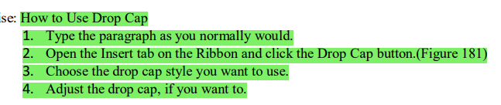
- Design Ribbon)
- Themes
- Style Set –
- Colors
- Fonts –
- Paragraph Spacing
- Effects
- Set As Default
- Page Background
- Page Color
- Page Borders
- Header and Footers are areas where you can add Text or Graphics A header is at the top margin; a footer is printed in the bottom margin of this page and all the pages in the document you will see same header and footer format.
- Bookmarks are a way to keep track of reading. They are similar to bookmarks you keep while reading a Favorite novel or story book like, turn the corner of the page or place pen or pencil
- Page Setup Group in Page Layout Ribbon)
- Indent Left
- Indent Right
- Spacing Before –
- Spacing After –
- (Arrange Group in Page Layout Ribbon
- Position - Drop-Down. Displays a list of picture positioning options. The drop-down contains the commands:
- Wrap Text
- Bring Forward
- Send Backward –
- Selection Pane –
- Align
- Group
- Rotate
- This tab gives you access to all the commands for creating references within your documents.
- Table of Contents
- Add Text
- Footnotes –
- Insert Footnote - (Alt + Ctrl + F).
- Insert Endnote - (Alt + Ctrl + D)
- Next Footnote
- Show Notes
- Proofing Group in Review Ribbon)
- Spelling & Grammar
- Thesaurus –
- Word Count –
- Language Group in Review Ribbon)
- Translate
- Language –
- (Comments Group in Review Ribbon)
- New Comment
- Delete
- Previous
- Next
- (Tracking and Changes Groups in Review Ribbon)
- Track Changes - (Ctrl + Shift + E)
- Show Markup
- Reviewing Pane
- Accept
- Reject
- Previous –
- Next
- MS-PowerPoint. This is used to develop presentations
- . The design ribbon is the ribbon that helps you to design your slides as per your requirement. The first group is called the: “Themes
- (Slides Group on Home Ribbon)
- New Slide
- Layout –
- Reset
- Delete
- book that keeps record of all transaction/ expenditures and income. Such a book can be called a manual or paper spreadsheet
- Spreadsheet is a tool that is used to organize data, such as a check register. Spreadsheets have been used for many, many years in business to keep track of expenses and other calculations
- : Microsoft Excel is an example of spreadsheet application program that can be used for storing, organizing and manipulating data
- Excel offers many types of charts including: Column, Line, Pie, Bar, Area, Scatter and more
- A formula is a set of mathematical instructions that can be used in Excel to perform calculations.
- Type “=” (the equal sign) and the formula
- “:” is used to specify the range of the cell on which you want to apply the formula
- IMP MCQS
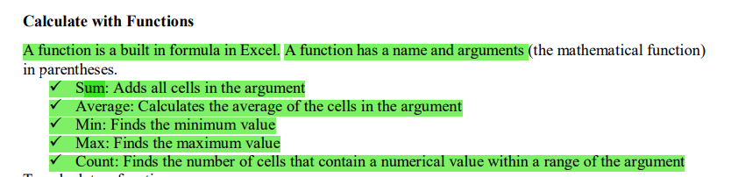

- . There are two types of sorts in Microsoft Excel i.e. Basic Sorts and Custom Sorts
Basic Sort
To execute a basic descending or ascending sort based on one column perform the following steps
: • Highlight the cells that will be sorted
• Click the Sort & Filter button on the Home tab
- Database is collections of files which are also referred as tables. Information is organized in these tables in the form of fields and records for easy access and management purpose.
- SQL stands for structured query language
- This is the most commonly used syntax for querying a relational database.
- External data tab is used to import, export, collect and share data between different databases
- . Each column in table is referred to as a field.
- IMP LONG+ MCQS
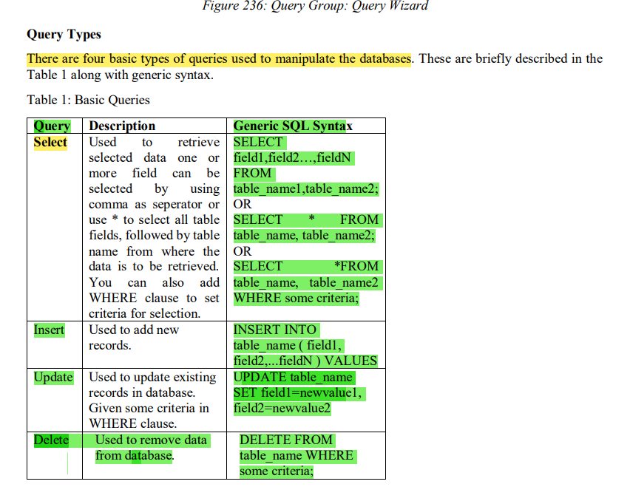
- A web page is nothing more than a file, a HTML file to be exact. It's called HTML because web page documents have the file extension .html or .htm
- HyperText Markup Language is a markup language
- HTML elements form the building blocks of all websites. HTML allows images and objects to be embedded
- IMP LONG QUESTION
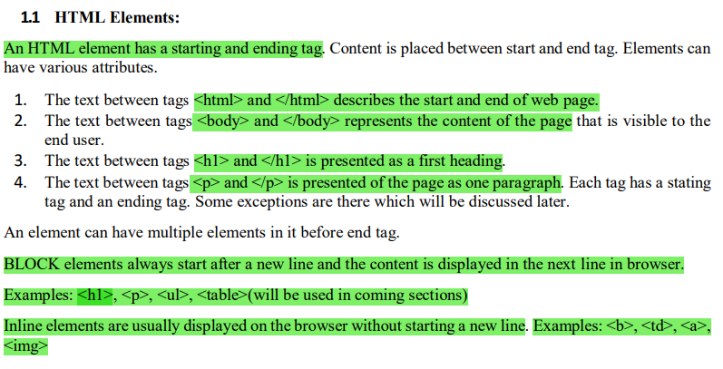
- width and height are attributes for image
- HTML editor is a software application for creating web page s CSS (Cascading Style Sheets), XML(Extensible Markup Language) and JavaScrip
- Adobe Dreamweaver is a web design and development application that provides a visual WYSIWYG editor (What You See Is What You Get)
- Dreamweaver is a powerful application for developing websites and mobile applications
- Bulleted lists might be familiar to you if you have worked with word processing or desktop publishing applications.
- Use the Unordered List button in the Property Inspector to create a bulleted list
- IMP SHORT QUESTION
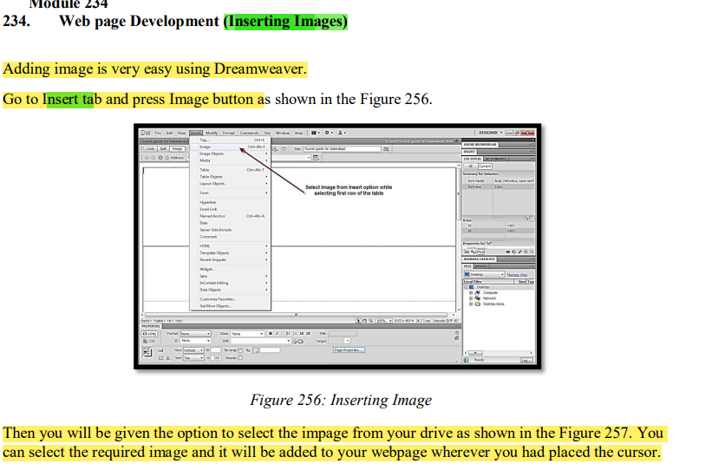
THE END

